Assignment 4

Omar Ahmed

UCID:30154382

Q1

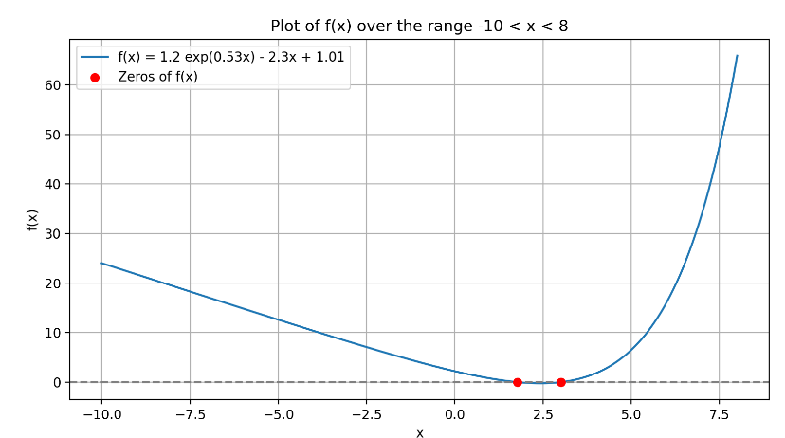Q2

Q3

Q4

Q5

Q6

Q7

